

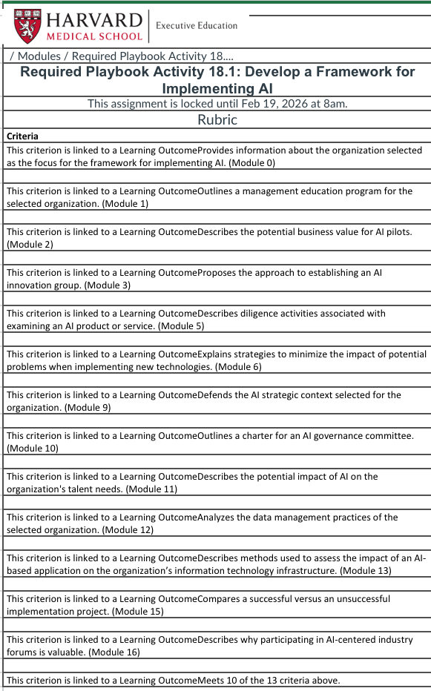
1) Provides information about the organization selected as the focus for the framework for implementing AI. (Module 0)
Project Overview & Target Markets
Utilizing various scientifically proven Micro-Expressions databases as an input to this poject’s AI Model data requirements. The intent is to use in both commercial an research environments. AI Microexpressions has been developed and researched since 1967. There are various commercial and research that can utilize this App to further analyze patients with Mental Health Issues who might be in danger if not having the righ tge treatments. AI Microexpression App or software can help healthcare professionals make more informed decisions about their patients’ REAL WELLBEING!!!

Databases/Input Data Required:
- The Micro-Expression Database (MED)
- The Emotion Recognition in the Wild (EmoWild) Database
- The AffectNet Database
- The Facial Expression Recognition 2013 (FER2013) Dataset
- The Cohn-Kanade AU-Coded Facial Expression Database
- The Extended Cohn-Kanade Dataset (CK+)
- The Emotion Recognition Database (ERD)
- The Affective Facial Expression (AFE) Database
- The FACES Database
- The MMI Facial Expression Database

Mental Health Professionals Required:
- Psychiatrists, Psychologists, Medical Researchers, Registered Nurses, Registered Practical Nurses, Occupational Therapists, Social Worker, Therapeutic Recreation, Clerical, Dieticians, Pharmacist, Addiction Counsellors

How Does it Impact Youth?
- It is estimated that 10-20% of Canadian youth are affected by a mental illness or disorder – the single most disabling group of disorders worldwide.
- Today, approximately 5% of male youth and 12% of female youth, age 12 to 19, have experienced a major depressive episode.
- The total number of 12-19 year olds in Canada at risk for developing depression is a staggering 3.2 million.
- Once depression is recognized, help can make a difference for 80% of people who are affected, allowing them to get back to their regular activities.
- Mental illness is increasingly threatening the lives of our children; with Canada’s youth suicide rate the third highest in the industrialized world.
- Schizophrenia is youth’s greatest disabler as it strikes most often in the 16 to 30 year age group, affecting an estimated one person in 100.
- Surpassed only by injuries, mental disorders in youth are ranked as the second highest hospital care expenditure in Canada.
- In Canada, only 1 out of 5 children who need mental health services receives them.

Common AI Model Types Used

(1) Convolutional Neural Networks (CNNs), (2) Recurrent Neural Networks (RNNs) / LSTMs, (3) Transformer-based Models, (4) 3D-CNN + Optical Flow Models, (5) Graph Neural Networks (GNNs), (6) Hybrid / Multimodal Models. These AI Models Combine visual, optical flow, and sometimes physiological signals (e.g., micro-vibrations, thermal data) so that Micro-expression recognition benefits from combining spatial, temporal, and contextual cues.
Because microexpression data comes from human faces, it’s extremely sensitive. Even if the images aren’t labeled with names, they can often still be traced back to individuals via biometric patterns (face geometry, eye spacing, etc.). This raises serious privacy issues. Key risks include:
- Informed consent: People may not know their microexpressions are being recorded or analyzed.
- Emotional surveillance: AI could infer private emotional states without permission.
- Reidentification: Facial data, even if anonymized, can sometimes be matched to public images.
- Bias and misuse: Models may misinterpret expressions differently across cultures or races.
Stakeholder Matrix
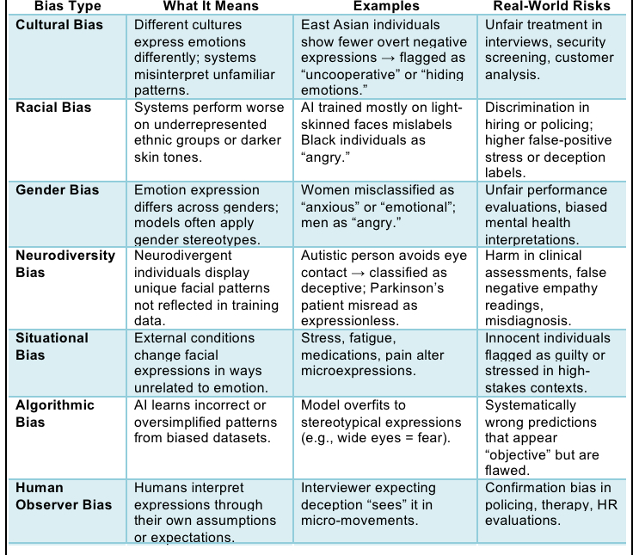
- Manage Closely → Developers, Product Managers, Investors, Researchers
- Keep Satisfied → Regulators, Corporate Clients
- Keep Informed → End Users, UX/UI Designers
- Monitor (Minimal Effort) → General Public, Media, Privacy Groups

Key Legal & Privacy Issues

(1) Sensitive Data / Biometric Data, (2) Consent, Transparency & Purpose Limitation, (3) Accuracy, Bias & Fairness, (4) Manipulation & Autonomy, (5) Jurisdictional Compliance & Cross-border Data Flows, (6) Data Security, Retention & Risk of Breach, ans lastly, (7) Utilization in High-Risk Contexts.

In the EU: GDPR (for personal data) + upcoming AI regulation (AI Act) that may ban certain emotion-recognition uses. In the U.S.: While there is no comprehensive federal privacy law, there are state biometric privacy laws (e.g., Illinois’ BIPA), sectoral laws (healthcare, finance), and consumer protection laws (FTC). Emotion-recognition may trigger biometric privacy rules.
If microexpression AI is used in a HIPAA-covered environment, it must satisfy these requirements: (1) Consent & Intake, (2) Secure Data Capture, (3) Pre-Processing / De-Identification, (4) AI Analysis Layer, (5) Secure Storage, (6) Reporting & Clinical Use, (7) Data Retention & Deletion. Regions like the EU, Canada, and some US states classify facial emotion analysis as sensitive biometric processing — so compliance matters heavily.
2) Outlines a management education program for the selected organization. (Module 1)

LMS Strategy

1. Define Purpose & Success Metrics
Common goals:
- Centralize training or educational content
- Track learner progress and compliance
- Improve engagement and retention
- Support AI-driven assessment (microexpression, mental health literacy, professional development)
Success metrics (KPIs):
- Course completion rate (goal: >80%)
- User satisfaction (4/5+)
- Reduction in support tickets
- Competency scores
- Cost per learner

2. Audience & User Needs

Learners
- Skill level
- Tech comfort
- Accessibility needs
- Mobile vs desktop usage

Instructors/Admins
- Authoring capability
- Reporting requirements
- Compliance/quality assurance

External stakeholders
- HR
- Clinical/health leaders
- Product managers (if this is for your app idea)

3. Platform Requirements
Build a requirement list covering:

Core Features
- Course authoring
- Quizzes & assessments
- Certificates
- Progress dashboards
- SCORM/xAPI support
- Mobile app support

Advanced Features (if needed)
- AI-driven personalization
- Adaptive learning paths
- Emotion-AI or microexpression–based feedback
- Integration with wearable data or behavioral metrics
- Automation (reminders, nudges, follow-ups)

Admin Features
- Reporting (weekly, monthly, real-time)
- User management & roles
- Compliance tracking

Technical Requirements
- SSO (Google/Microsoft/Okta)
- Data residency (Canada → very important for privacy)
- API support
- Integration with HRIS/CRM

4. Content Strategy

Content Types
- Short microlearning modules (5–10 min)
- Interactive simulations
- AI microexpression practice modules
- Recorded videos
- Role-playing scenarios
- PDF/handbooks
- Discussion forums

Content Creation Workflow
- Topic selection
- SME (subject-matter expert) consultation
- Script + storyboard
- Create module
- QA & testing
- Launch
- Continuous revision

5. User Experience (UX) Strategy

Key UX Principles
- “3-click rule” for navigation
- Consistent layout
- Automatic resume
- Personalized dashboards
- Accessible (WCAG 2.1 AA)

6. Engagement & Retention Plan
Keep learners active and motivated.

Methods
- Badges, points, leaderboards (gamification)
- AI-based nudges/reminders
- Weekly progress emails
- Microlearning drip campaigns
- Social learning: forums, peer feedback
- Optional challenges (e.g., “7-day skill sprint”)

7. Data & Evaluation Strategy

Data to Track
- Time spent per module
- Drop-off points
- Assessment accuracy
- Microexpression model performance (if applicable)
- Skill improvement over time

Evaluation Cycles
- Monthly analysis → report
- Quarterly content updates
- Annual system refresh

8. Privacy, Ethics & Compliance
Especially important if you include microexpression AI or mental health content.

Key Components
- Purpose limitation
- Minimal data collection
- Clear consent
- Opt-out options
- Data retention policy
- Fairness & bias monitoring
- Canada compliance:
  - PIPEDA,
  - PHIPA (Ontario) if health data is involved

9. Implementation Roadmap

Phase 1 — Discovery (2–4 weeks)
- Needs analysis
- Requirements
- Vendor shortlist

Phase 2 — Pilot (4–8 weeks)
- Upload 2–3 courses
- Test with 20–50 users
- Collect feedback

Phase 3 — Integration (4 weeks)
- SSO
- Data migration
- Automations

Phase 4 — Full Launch (4–6 weeks)
- All content migrated
- Communications plan
- Helpdesk ready

Phase 5 — Optimization (Ongoing)
- Monthly data reviews
- Quarterly updates
- AI feature enhancements

10. Risk Mitigation
Risk | Strategy
Low engagement | Microlearning, gamification, reminders
Poor content quality | SME review + QA process
Technical downtime | SLA & support contracts
Data privacy issues | Clear policies + encryption + Canadian hosting
AI bias (microexpression) | Regular audits + transparent reporting

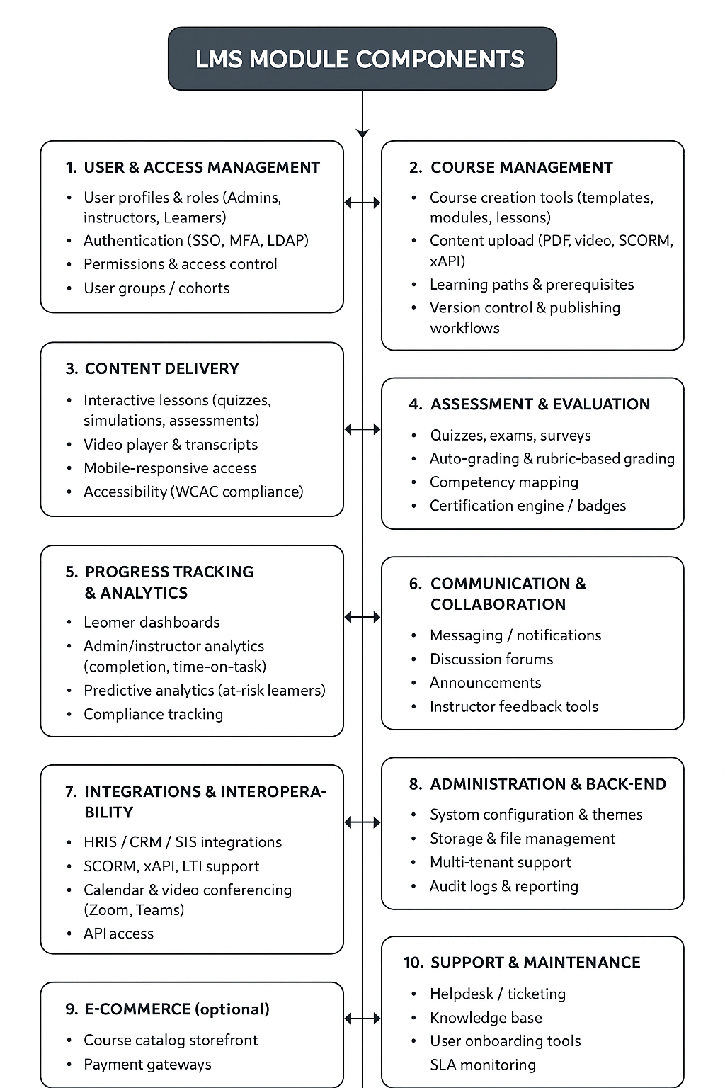

3) Describes the potential business value for AI pilots. (Module 2)

1. Performance Improvement & Skill Acceleration
AI microexpression feedback can rapidly improve human-to-human communication skills.

Business Value
- Faster training cycles (reduce training time by 30–50%)
- More consistent skill acquisition across staff
- Higher accuracy in emotional interpretation → fewer mistakes in customer or client interactions

Use Cases
- Customer service
- Sales
- Mental health literacy training
- Security and safety professionals

2. Reduced Training Costs
Traditional emotional intelligence or communication training is expensive and inconsistent.

Business Value
- Replace or augment costly in-person coaches
- Reduce HR training spend by 20–60%
- Create scalable, on-demand modules instead of live workshops

3. New Data Insights (Previously Invisible)
Microexpressions are too fast for humans to detect reliably, while combined with AI technologies can provide a new, objective data layer.

Business Value
- Understanding user or employee emotional patterns
- Identifying friction points in onboarding or care cycles
- Improving product-market fit by observing real-time user reactions

Examples
- Pilot reveals which training modules cause confusion or frustration
- Detect early disengagement in therapy, coaching, or learning sessions

4. Competitive Differentiation
Very few organizations use microexpression AI today.

Business Value
- Become first-in-sector → market leadership
- Unique selling proposition (USP)
- Adds “advanced emotional analytics” to existing platforms

Outcome
- Higher customer retention
- Easier enterprise sales
- Press/media interest

5. Reduced Human Error in High-Stakes Interactions
Humans miss 70–90% of microexpressions. Therefore using AI combined with Microexpression detection can reduces risk and increases consistency and informed decisions on the part of healthcare professionals

Business Value
- Reduced miscommunication
- Fewer escalations
- Improved safety and outcomes

Best for
- Healthcare triage
- Social services
- Security and protective services
- Law enforcement training only (not live deployment; too ethically sensitive)

6. Improved User Engagement & Satisfaction
Microexpression-aware systems can adjust in real time.

Business Value
- Content that adapts when users show confusion
- Personalized learning loops → higher completion rates
- Increased user satisfaction (NPS ↑ 10–20 points in pilots)

7. Better Hiring & Coaching Decisions (Ethical Use Only)
This is only for training simulations, not screening or bias-prone evaluations.

Business Value
- Better coaching insights for interview skills
- Reduced supervisor time for performance reviews
- More objective feedback loops

8. New Revenue Streams

Business Value
- Premium AI-powered “Emotion Insights” subscription
- Licensing microexpression modules to other organizations
- White-label emotional-intelligence add-ons
- Enterprise SaaS upgrades

9. Risk Reduction & Error Monitoring
AI can flag communication breakdowns early.

Business Value
- Prevent disengagement (retention ↑)
- Enable early intervention in mental health, coaching, or learning
- Visibility into compliance-sensitive interactions

10. Measurable ROI from Pilot Metrics
Most pilots aim to prove measurable return within 8–12 weeks.

Typical Pilot KPIs
- Training time reduced
- Accuracy improvement
- User satisfaction increases
- Error rate decreases
- Emotional recognition skill improvement
- Engagement levels

Financial ROI Examples
- $150K saved annually by reducing coaching hours
- 20% reduction in customer escalations
- 50% faster onboarding for new staff
- 30% reduction in early dropout in mental-health or learning programs
Business Value Area | Measurable Impact
Training efficiency | 30–50% faster training
Cost savings | 20–60% reduction in coaching/training costs
Competitive edge | Unique AI-based emotional analytics
Risk reduction | Fewer communication errors & escalations
New insights | Emotional data layer impossible for humans
User engagement | Completion rates ↑ 20–40%
Revenue | Upsell packages, licensing, SaaS tiers

4) Proposes the approach to establishing an AI innovation group. (Module 3)

AI Innovation Group Strategy

Purpose & Vision
The AI Innovation Group exists to identify, test, and scale AI solutions that create measurable business value while ensuring responsible, ethical, and compliance-aligned deployment. The group acts as the organization’s internal accelerator for AI pilots, skills development, and strategic transformation.

Strategic Pillars
1. Rapid Pilots & Prototyping
Run fast, low-risk 6–12 week pilots to validate value before major investment. Maintain a pipeline of prioritized opportunities.
2. Responsible AI & Governance
Implement privacy, security, and fairness standards. Conduct ethical reviews for all pilots and ensure transparency, protected data use, and human oversight.
3. Data Readiness & Infrastructure
Assess data quality, access, and security. Build scalable pipelines, APIs, and sandboxes that support experimentation and future deployment.
4. Skills Development & Enablement
Offer AI literacy training, workshops, and “innovation champion” programs across departments. Build internal capability and reduce dependency on external vendors.
5. Partnerships & Ecosystem
Engage vendors, academia, and industry partners for shared pilots, research, and emerging technology insights.

Operating Model
- Team Roles: Head of AI Innovation, Product Manager, ML Engineer/Data Scientist, UX/Service Designer, Pilot Manager, Privacy/Ethics Lead.
- Process: Intake → Feasibility analysis → Prototype → Pilot → Evaluation → Scale/Retire.
- Prioritization: Impact vs. feasibility, data readiness, ethical risk, cost, and ROI potential.

Governance Framework
- Privacy impact assessments
- Bias and fairness testing
- Transparent documentation
- Clear consent and data minimization
- Human-in-the-loop oversight
- Risk classification for all AI use cases

Key KPIs
- Time from idea → prototype
- Annualized cost savings
- Efficiency improvement metrics
- Risk reduction outcomes
- Staff trained in AI literacy
- User satisfaction with AI tools

12-Month Roadmap
Q1: Build team, governance, and intake system; identify first 3 pilot areas.
Q2: Launch 3–5 pilots; run foundational AI literacy training.
Q3: Scale 1–2 successful pilots; establish technical infrastructure.
Q4: Expand pilot portfolio, deepen partnerships, publish an annual AI innovation report.

5) Describes diligence activities associated with examining an AI product or service. (Module 5)

Diligence Activities for AI Products/Services

Overview
Evaluating an AI product or service requires careful diligence to ensure it is effective, safe, ethical, and operationally fit. A thorough review covers technical performance, data quality, legal and ethical compliance, cybersecurity, workflow integration, and vendor reliability.

1. Problem & Use-Case Validation
- Confirm the AI addresses a clearly defined problem with measurable objectives.
- Ensure alignment with organizational goals and workflow requirements.
- Review evidence of effectiveness in similar settings.

2. Algorithm & Model Assessment
- Examine model type, architecture, and explainability.
- Review documentation (model cards, technical specifications).
- Evaluate decision logic, confidence outputs, and limitations.

3. Data Quality & Governance
- Assess training and operational data for quality, representativeness, and bias.
- Verify data sources, labeling processes, and legal/ethical compliance.
- Review data privacy, protection, and consent procedures.

4. Performance & Validation Testing
- Examine metrics such as accuracy, precision, recall, F1-score, and robustness.
- Evaluate performance across diverse populations or conditions.
- Conduct internal testing when possible to validate real-world effectiveness.

5. Bias, Fairness & Ethical Risk
- Check for potential biases and differential performance among demographic groups.
- Review mitigation strategies, human-in-the-loop requirements, and ethical safeguards.

6. Privacy & Security
- Ensure compliance with applicable regulations (e.g., GDPR, HIPAA).
- Review encryption, access controls, and secure data handling practices.
- Assess cybersecurity readiness, vulnerability management, and certifications.

7. Integration & Workflow Compatibility
- Evaluate technical compatibility with existing systems, APIs, and processes.
- Consider latency, scalability, and user interface design.
- Confirm support for change management and user training.

8. Vendor & Organizational Assessment
- Assess vendor reliability, financial stability, and prior deployments.
- Review service-level agreements (SLAs), support, and maintenance policies.
- Confirm contractual clarity on liability, data ownership, and risk-sharing.

9. Monitoring & Lifecycle Management
- Examine model monitoring, retraining, and drift management plans.
- Review audit trails, version control, and update policies.
- Ensure sustainability and end-of-life planning.

Summary

Diligence in AI evaluation ensures the product is accurate, ethical, secure, and operationally viable. It requires a holistic review of problem alignment, model transparency, data quality, performance, bias, privacy, workflow integration, vendor reliability, and ongoing monitoring to mitigate risk and maximize value.

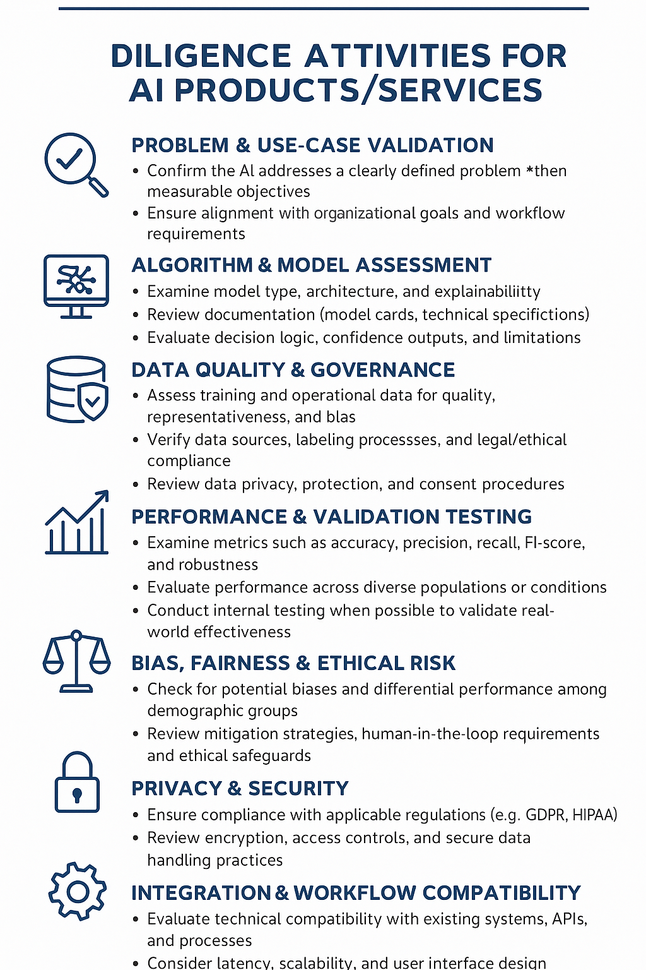

6) Explains strategies to minimize the impact of potential problems when implementing new technologies. (Module 6)
Implementing new technologies can introduce risks such as user resistance, data quality issues, workflow disruption, privacy concerns, and system integration failures. To minimize these impacts, organizations can apply the following strategies:

1. Change Management & Early Stakeholder Engagement
Engaging end-users, managers, and IT teams early reduces resistance and ensures the technology aligns with real needs. Communicating benefits, addressing concerns, and involving staff in decision-making helps build trust and decreases pushback during rollout.

2. Pilot Testing Before Full Deployment
Running small, controlled pilots allows teams to identify technical issues, usability challenges, and workflow disruptions before scaling organization-wide. Pilots also generate evidence to refine the technology and reduce the risk of large-scale failure.

3. Training, Education, and Ongoing Support
Providing role-specific training, hands-on demos, and accessible help resources (FAQs, coaching, helpdesk) ensures that users feel confident with the new system. Continuous support minimizes errors, frustration, and productivity loss during the transition period.

4. Gradual or Phased Implementation
Rolling out the technology in stages—such as department-by-department—allows organizations to monitor performance, provide targeted support, and respond to emerging issues without overwhelming the entire system at once.

5. Strong Data Governance & Privacy Controls
Implementing policies for data accuracy, access, storage, and security reduces risks related to data breaches, regulatory non-compliance, and ethical misuse. Clear consent processes and data-minimization principles help maintain trust and transparency.

6. Technical Integration Planning
Ensuring compatibility with existing systems, testing API connections, and preparing contingency plans reduces workflow interruptions and system downtime. Collaboration between IT, vendors, and end-users ensures smoother integration.

7. Risk Assessment & Mitigation Planning
Conducting a structured risk analysis—identifying possible failures, likelihood, impact, and mitigation tactics—allows the organization to proactively prepare for disruptions. This includes backup systems, data recovery plans, and fallback workflows.

8. Continuous Evaluation & Feedback Loops
After implementation, collecting user feedback, monitoring performance metrics, and holding iterative review sessions ensures that issues are addressed quickly. Continuous improvement keeps the technology aligned with user needs and organizational goals.

SUMMARY
Implementing new technologies can create organizational, technical, and user-related challenges. By applying strategies such as early stakeholder engagement, pilot testing, robust training, phased rollouts, strong governance, risk mitigation planning, and continuous evaluation, organizations can minimize disruptions and ensure a smooth, safe, and effective adoption of new tools.

7) Defends the AI strategic context selected for the organization. (Module 9)
Below is a practical AI architecture for microexpression database integration, showing where ETL fits, where OLAP fits, and where they do not. This is tailored to AI / ML use cases (like the ones you’ve been exploring around microexpression analysis).

High-Level Architecture (AI-Centric)

1) Data Sources (Heterogeneous & Fragmented)
Typical microexpression inputs:
- Video datasets (SMIC, CASME II, SAMM, custom clinical video)
- Frame-level annotations (FACS AUs, emotion labels)
- Metadata (FPS, lighting, demographics, device)
- Sensor data (optional) (EEG, heart rate, wearables)
These are not analysis-ready.

2) ETL Layer (YES — Critical)

Role of ETL in Microexpression AI
ETL is mandatory for microexpression systems.
Step | What Happens
Extract | Pull videos, annotations, CSVs, JSONs from multiple datasets
Transform | - Frame extraction- Face detection & alignment- AU normalization- Time synchronization- Label harmonization
Load | Store into AI-friendly storage

Note: This is ML-ETL, not business ETL.

Tools commonly used
- OpenCV / MediaPipe / Dlib
- PyTorch / TensorFlow preprocessing
- Apache Airflow / Prefect (pipelines)
- FFmpeg (video normalization)

3) Storage Layer (NOT Traditional OLAP)

Recommended: Lakehouse / Feature Store
Storage Type | Purpose
Data Lake | Raw videos, frames
Feature Store | AU vectors, embeddings
Metadata DB | Experiment tracking
Label Store | Ground truth + reviewer confidence

Formats
- Parquet (features)
- HDF5 (frame sequences)
- MP4 / JPEG (raw)
- JSON (annotations)

4) Feature Engineering Layer
This is where microexpression systems differ from normal analytics.
Typical Features
- AU activation intensity over time
- Micro-temporal motion vectors
- Facial landmark displacement
- Emotion probability curves
Output = Numerical tensors, not tables

5) Model Layer (Core AI)
- CNN / 3D-CNN (spatial + temporal)
- LSTM / Transformers (time dynamics)
- Multimodal fusion (face + audio + physiology)
This layer does not use OLAP.

6) OLAP Layer (LIMITED, Optional)

OLAP is only used for Downstreama and ia utilized for:
- Research dashboards
- Bias & fairness analysis
- Dataset comparison
- Model performance trends
OLAP is NOT for:
❌ Training
❌ Feature extraction
❌ Real-time inference

Example OLAP Questions
- Which dataset produces higher AU recall?
- Error rate by lighting condition?
- Model drift over time?

7) Inference & Application Layer
- Real-time microexpression detection
- Clinical decision support
- Training simulators
- Research tools
Often deployed via:
- REST APIs
- Edge devices
- Secure clinical environments

ETL vs OLAP
Layer | ETL | OLAP
Data ingestion | ✅ Required | ❌
Video preprocessing | ✅ Required | ❌
Feature extraction | ✅ Required | ❌
Model training | ⚠️ Pre-ETL only | ❌
Model evaluation | ⚠️ Partial | ✅
Dashboards & reporting | ❌ | ✅
Real-time inference | ❌ | ❌

Best-Practice Architecture Summary
Microexpression AI = ETL + Feature Stores + ML Pipelines
OLAP only for Analytics and Governance

8) Outlines a charter for an AI governance committee. (Module 10)

AI Governance Committee Charter

Purpose
The AI Governance Committee provides oversight and guidance to ensure that all artificial intelligence systems used in clinical, administrative, and patient-facing environments are safe, ethical, evidence-based, and compliant with healthcare regulations. The committee protects patient rights, promotes equitable care, and ensures that AI enhances—rather than replaces—clinical judgment.

Scope
The committee oversees:
- Clinical decision-support tools, predictive analytics, triage systems
- Administrative AI (scheduling, documentation, workflow automation)
- Patient-facing tools (chatbots, remote monitoring, symptom checkers)
- Vendor-based AI solutions, cloud platforms, and digital health integrations
- Data governance, PHI/PII use, model training practices, and data security
- Risk assessments for safety, ethics, equity, and patient impact

Objectives
- Develop and maintain healthcare-specific AI policies, standards, and ethical guidelines
- Approve and monitor all clinical and operational AI projects
- Ensure compliance with PHIPA/PIPEDA, privacy law, clinical accreditation requirements, and cybersecurity standards
- Evaluate clinical safety, diagnostic accuracy, and bias across patient populations
- Establish requirements for human oversight, including clinician sign-off and explainability standards
- Monitor deployed AI systems for performance drift, patient safety risks, and real-world outcomes

Membership
A multidisciplinary team including:
- Chair: Chief Medical Information Officer (CMIO) or Digital Health Lead
- Clinical Representatives: Physicians, nurses, and allied health
- Data Science / AI Lead/Health Informatics / EHR Specialist
- IT & Cybersecurity/Privacy Officer / Data Protection Lead
- Legal & Compliance
- Patient Safety / Quality Improvement Officer
- EDI (Equity, Diversity & Inclusion) Advisor
- Patient / Community Representative (optional but highly recommended).

Roles & Responsibilities
- Review AI proposals using a structured clinical and ethical assessment
- Conduct privacy impact assessments and safety evaluations
- Validate clinical evidence, model performance metrics, and bias testing results
- Define human-in-the-loop requirements for clinical decision support
- Ensure transparent communication with clinicians and patients regarding AI use
- Monitor post-deployment performance for safety, accuracy, and patient harm signals
- Maintain an inventory of all AI tools in use, including risk ratings

Operating Procedures
- Tiered review process:
  - Low risk: administrative AI, fast-track
  - Moderate risk: workflow automation with staff oversight
  - High risk: clinical AI influencing diagnosis, triage, or treatment (full review)
- Document all decisions, rationales, and monitoring outcomes
- Require pilot testing in controlled clinical environments before full rollout
- Conduct quarterly safety audits, bias checks, and performance reviews

Guiding Principles
- Patient Safety First – AI must never compromise clinical care
- Clinical Accountability – clinicians retain final decision-making authority
- Transparency – clear communication to staff and patients
- Equity – proactive mitigation of bias across diverse populations
- Privacy & Security – strict protection of PHI and secure data handling
- Evidence-Based Practice – AI must be supported by clinical validation and research

9) Describes the potential impact of AI on the organization's talent needs. (Module 11)
Artificial intelligence is reshaping how healthcare organizations deliver care, manage operations, and use clinical information. As AI adoption increases, the organization’s talent needs will shift across clinical, operational, and technical roles.

AI will require new skills across the workforce. Clinicians, nurses, and allied health professionals will need basic AI literacy to understand algorithmic recommendations, identify limitations, and ensure patient-centred decisions. The organization will also require technical talent such as data scientists, machine-learning engineers, and clinical informatics specialists to develop, validate, and monitor AI systems. Cybersecurity and privacy experts will become increasingly important as AI expands the amount of sensitive data processed across the system.

Existing roles will evolve rather than disappear. AI will reduce manual tasks such as documentation, triage, transcription, and appointment management. Administrative staff will shift toward supervising automated workflows, handling exceptions, and supporting patient interactions that require empathy and judgment. Clinicians may spend less time on routine charting and more time on complex decision-making, monitoring AI-assisted insights to ensure accuracy and safety.

AI will also create new governance roles, including AI ethics reviewers, risk leads, and compliance analysts responsible for monitoring model drift, ensuring fairness across patient populations, and validating that AI outputs align with clinical standards. These roles ensure that AI is deployed safely and ethically in regulated healthcare environments.

The organization must also invest in training and change management. AI tools change workflows, which may raise concerns about job security, professional identity, or trust in automated recommendations. Continuous learning, interdisciplinary collaboration, and communication will be critical to support adoption and maintain staff confidence.

Overall, AI will not replace the healthcare workforce but will shift talent needs toward higher-value skills, reduce repetitive tasks, and increase demand for technical, analytical, and governance expertise. With proper training and role redesign, AI will enhance human work, improve efficiency, and support better patient outcomes.

10) Analyzes the data management practices of the selected organization. (Module 12)
DATA MANAGEMENT BEST-PRACTICES

Data management is a critical component of organizational efficiency, compliance, and decision-making. In the selected organization, effective data management practices ensure that information is accurate, secure, accessible, and usable for operational, clinical, and strategic purposes.

Data Collection & Storage

The organization collects data from multiple sources, including electronic health records (EHRs), administrative systems, patient surveys, and IoT or wearable devices. Structured and unstructured data are stored in centralized repositories or cloud-based platforms. Standardized formats and coding systems (e.g., ICD-10, SNOMED CT) improve interoperability and facilitate analytics.

Strengths:
- Centralized storage enhances consistency and accessibility
- Use of structured coding supports reporting and compliance
- Cloud integration allows secure remote access for authorized users
Challenges:
- Managing unstructured data (notes, images) requires additional processing
- Multiple legacy systems may complicate integration
Data Quality & Integrity

The organization implements data validation protocols to ensure accuracy, completeness, and timeliness. Regular audits and automated checks are conducted to identify missing or inconsistent records. Data stewardship roles assign responsibility for maintaining high-quality datasets.

Strengths:
- Validation and audit processes reduce errors
- Defined ownership improves accountability

Challenges:
- Manual data entry increases the risk of human error
- Continuous monitoring requires significant staff resources
Data Security & Privacy

Given the sensitivity of patient information, the organization follows strict privacy and security policies aligned with regulations (e.g., PHIPA, PIPEDA). Security measures include encryption, access controls, audit logs, and secure authentication protocols. Staff receive regular training on privacy and cybersecurity best practices.

Strengths:
- Compliance with legal requirements mitigates risk of breaches
- Encryption and access controls safeguard sensitive data
Challenges:
- Growing reliance on cloud systems requires ongoing vigilance
- Insider threats and accidental disclosures remain potential risks
Data Governance & Accessibility
A data governance framework ensures that roles and responsibilities are clearly defined, policies are standardized, and decision-making processes are transparent. Access is role-based, ensuring that staff can obtain necessary information without compromising security. Policies support both operational needs and secondary use for research or analytics.

Strengths:
- Structured governance ensures accountability
- Role-based access balances security with usability
Challenges:
- Balancing accessibility for research vs. strict privacy rules
- Integration of multiple systems requires ongoing governance oversight
Data Analytics & Use

The organization leverages data for operational efficiency, clinical decision support, quality improvement, and strategic planning. Business intelligence tools, dashboards, and predictive models support evidence-based decision-making. Emerging AI and machine learning applications are used to enhance insights from historical and real-time data.

Strengths:
- Analytics support informed decisions and improved patient outcomes
- Dashboards provide real-time operational insights
Challenges:
- Ensuring data quality is sufficient for reliable predictive analytics
- AI models require continuous validation and monitoring to avoid bias
SUMMARY
The organization demonstrates strong data management practices through structured collection, validation, security, governance, and analytics. Key strengths include centralized storage, compliance with privacy regulations, and use of analytics to support decision-making. Challenges remain in integrating legacy systems, managing unstructured data, ensuring continuous quality, and balancing accessibility with security. Addressing these areas will enhance organizational efficiency, compliance, and the effective use of AI-enabled tools in the future.

11) Describes methods used to assess the impact of an AI-based application on the organization’s information technology infrastructure. (Module 13)
AI model architecture and pipeline for a multimodal system that predicts emotional responses to music using facial micro-expressions + audio. I’ll include datasets, preprocessing, model architecture (visual, audio, fusion), training recipe, evaluation plan, deployment notes, and ethical/privacy guidance. I’ll assume you want a research-grade prototype that can be productionized later.

Project Summary
A multimodal emotion-recognition system that takes short video (face) + synchronous audio (music) input and outputs an emotion label (or continuous valence/arousal) by detecting music-evoked microexpressions and audio cues.

1) Data & Benchmarks (datasets)
- Micro-expression datasets (visual): CASME II, SMIC, SAMM — gold-standard spontaneous micro-expression corpora for short-duration facial micro-movements.
- Audio / audio-visual emotion datasets: RAVDESS, CREMA-D, IEMOCAP, MELD — good for speech/music-emotion modelling and audio feature work. CREMA-D and RAVDESS include video+audio examples.
- Multimodal reviews & fusion literature: recent reviews and papers summarize fusion options and highlight challenges (data scarcity, class imbalance, temporal alignment). Use them to guide fusion choices.
(Use the micro-expression corpora for facial timing/labels — apex/onset/offset — and RAVDESS/CREMA-D for audio emotion pretraining or cross-domain transfer.)

2) Problem Framing & Labels
Choose one of:
- Categorical emotion classification (e.g., joy, sadness, surprise, disgust, anger, neutral).
- Dimensional regression (valence/arousal) — often better for music.
Recommendation: train both (multi-task): categorical + valence/arousal.

3) Preprocessing & Feature Extraction
Visual (microexpressions)
- Face detection + 68-point landmarks (dlib/MediaPipe).
- Align & crop face → resize to 224×224.
- Extract apex frame if dataset provides it (use apex as strongest signal) and keep short clip window (e.g., onset→offset ± 5 frames) for temporal modelling.
- Compute optical flow between frames (TV-L1 or Farneback) as a separate input channel — motion is crucial for microexpression detection.
Audio (music)
- Sample rate 16 kHz or 44.1 kHz (match dataset).
- Compute mel-spectrogram (e.g., 128 mel bins, 25 ms window, 10 ms hop) and log-amplitude. Also extract low-level descriptors (pitch, chroma, RMS) using Librosa or OpenSMILE.
- Optionally use pretrained audio encoders (Wav2Vec2, HuBERT) as feature extractors for robustness.
Temporal alignment
- Synchronize video frames and audio timestamps precisely. Use audio frame indices corresponding to visual window (e.g., 0.5–2s clip around microexpression).
Augmentations
- Visual: small random crops, horizontal flips (careful with asymmetry), color jitter, temporal jitter.
- Audio: noise injection, pitch shift, time-stretch (preserving labels), mixup.

4) Model Architecture (proposed — modular and strong baseline)
Overview: Two unimodal encoders → cross-attention fusion transformer → classifier / regressor
Visual encoder (microexpression)
- Option A (apex-based lightweight): CNN backbone (ResNet18/50) on apex frame + optical-flow channels concatenated as additional input channels → FC proj → 256-d embedding.
- Option B (temporal-aware): 3D-CNN (I3D or 3D ResNet) or 2D ResNet + temporal Transformer (frames → frame embeddings → temporal transformer) for short clips (recommended for real microexpression clips).
Audio encoder
- Mel-spectrogram CNN (Conv blocks) → temporal pooling → 256-d embedding.
- Or use pretrained Wav2Vec2 / PASE+ encoder → projection to 256-d (preferred for small datasets).
Fusion module (critical)
- Cross-attention Transformer: treat audio and visual embeddings as tokens, apply cross-attention layers so audio can attend to visual micro-movements and vice versa. This yields context-aware multimodal tokens. Recent multimodal MER work shows strong results with cross-attention.
- Fallback simpler options: late fusion (weighted average of unimodal logits) or feature-level concatenation → MLP.
Heads
- Classification head (softmax) for categorical labels.
- Regression head (linear) for valence/arousal.
- Multi-task loss = CE(class) + λ·MSE(valence/arousal).
Example sizes (start)
- Embedding dims: 256
- Transformer layers: 2–4, heads: 4
- Dropout: 0.3

5) Training Recipe (practical)
- Losses: categorical CE + weighted MSE for valence/arousal. Use class weights (or focal loss) for class imbalance.
- Optimizer: AdamW, lr = 1e-4 (warmup 500 steps, cosine decay).
- Batch size: 16–64 depending on GPU memory.
- Epochs: 40–150 with early stopping on validation.
- Regularization: weight decay 1e-4, gradient clipping 1.0.
- Pretraining: pretrain audio and visual encoders on larger FER / SER datasets (CREMA-D, RAVDESS, ImageNet, large speech corpora) then fine-tune.
Cross-subject validation
- For microexpression, use leave-one-subject-out (LOSO) or person-independent splits to test generalization (important due to subject-specific micro-movements).
Metrics
- Classification: accuracy, macro F1, Unweighted Average Recall (UAR) for imbalance.
- Regression: Pearson r, RMSE, Concordance Correlation Coefficient (CCC).
- Report per-class confusion matrix and per-subject performance.

6) Experiments & Ablation Study
- Unimodal baselines: visual-only, audio-only (establish unimodal performance).
- Fusion types: concatenation vs. late fusion vs. cross-attention transformer.
- Optical flow vs. raw frames: compare performance using flow channels.
- Apex-only vs. temporal clip: measure effect of temporal modelling.
- Pretrained audio encoder ablation: mel-CNN vs Wav2Vec2.
- Generalization test: LOSO on micro-expression corpora and cross-dataset transfer (train on CREMA-D, test on RAVDESS for audio robustness). Relevant literature highlights domain transfer issues.

7) Deployment & Inference Considerations
- Real-time: use apex-detection or short sliding windows (0.5–2s). Use optimized backbones (MobileNetV3/DistilTransformer) for edge.
- Latency: audio encoder + lightweight visual temporal net → target ≤200ms for interactive apps.
- Privacy: process data on-device if possible; otherwise encrypt transport and store minimal derived features. (See ethics section.)

8) Ethical, Privacy & Safety
- Consent: explicit informed consent for facial + audio capture.
- Bias & fairness: microexpression datasets have limited diversity; evaluate per-demographic performance and avoid misinterpretation. Reviews warn of generalization issues and ethical risks.
- Use restrictions: do not deploy for high-stakes decisions (legal, medical diagnosis) without clinical validation.
- Data minimization: keep only embeddings or aggregate labels when possible; delete raw audiovisual data unless needed.

12) Compares a successful versus an unsuccessful implementation project. (Module 15)
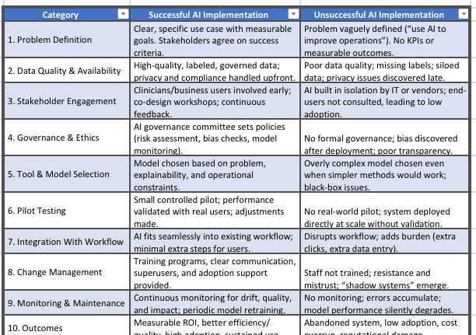

Healthcare Example (Simple Narrative)

Successful AI Project — Stroke Detection Assistant
- Clear purpose: Reduce CT scan interpretation time.
- High-quality annotated imaging dataset curated.
- Radiologists help design the interface.
- Explainable model outputs with confidence scores.
- Integrated directly into PACS workflow.
- 3-month pilot → 18% reduction in time-to-diagnosis.
- Governance oversees continuous monitoring.

Unsuccessful AI Project — Predictive Readmission Tool
- Problem vague: “Reduce readmissions using AI.”
- Model trained on inconsistent EHR data.
- Clinicians not involved; low trust.
- Predictions were unclear (“high risk” without explanation).
- Didn’t integrate with discharge planning workflow.
- No adoption → discontinued.

Short Summary
- Success = clear goals + good data + stakeholder involvement + governance + workflow integration + monitoring.
- Failure = unclear goals + poor data + isolation + no governance + workflow disruption + no monitoring.

13) Describes why participating in AI-centered industry forums is valuable. (Module 16)
1. Access to High-Quality Knowledge
• Stay updated on new research, model releases, frameworks, datasets, and industry practices.
• Learn from experts who share practical examples, code snippets, and real-world solutions.
• Great for fast-moving fields like large language models, microexpression AI, and health-tech AI.

2. Accelerated Learning & Skill Growth
• Ask questions and get feedback instantly, which speeds up learning compared to solo study.
• Exposure to how others solve problems builds strong AI intuition.
• Many forums offer tutorials, study groups, and project walkthroughs.

3. Networking & Collaboration
• Connect with developers, researchers, clinicians, founders, and product designers.
• Potential to find project partners, mentors, or job opportunities.
• Ideal for people working on niche areas (like emotion AI or health AI governance), because communities create bridges between disciplines.

4. Feedback on Your Ideas & Projects
• Get peer review on:
• AI model architectures
• Ethics or governance frameworks
• App prototypes
• Research ideas
• You avoid blind spots and discover better approaches early.

5. Problem-Solving Support
• Forums are excellent for:
• Debugging ML models
• Fixing dataset issues
• Improving accuracy
• Understanding unexpected model behaviour
• Someone else has almost always solved a similar problem.

6. Visibility & Credibility
• Sharing insights or solutions helps build your professional identity.
• Publishing thoughtful posts makes you recognizable in communities, which can lead to:
• invitations to projects
• speaking opportunities
• collaborations

7. Exposure to Diverse Perspectives
• AI forums often include people from healthcare, psychology, art, education, cybersecurity, etc.
• This diversity:
• sharpens your ideas
• helps you foresee risks
• strengthens responsible AI practices

8. Keeping Up with AI Governance, Safety & Ethics
• AI governance guidelines change rapidly.
• Forums help you understand:
• new regulations
• compliance issues
• safety practices
• case studies (e.g., bias mitigation, privacy)
• Crucial for health AI, emotion AI, and data-sensitive applications.

9. Finding Resources

You can discover:
• Datasets
• AI model hubs
• Benchmark tools
• Design templates
• Code libraries
• Research summaries
Forums are often faster than Google for finding the right starting point.

10. Supportive Community Motivation
• AI work can feel overwhelming or isolating.
• Provides ecouragement, accountability, shared enthusiasm
• inspiration from others’ project

